|  |  |  |  |  |  |  |  |  |  |
| --- | --- | --- | --- | --- | --- | --- | --- | --- | --- |
| **e-Project Report** | | | | | | | | | |
| **Institute Name** | Aptech education | | | | **Curriculum** | | | 7062 | |
| **­**  **Batch** | 2301D | **Semester** | | | | | | | 1st |
| **Course** | DISM | **Faculty / Mentor** | | | | Sir Azhar Ghafoor | | | |
| **Assigned on** | 16th May, 2023 | | **End Date** | | | 17th June, 2023 | | | |
| **Submitted to** | Sir Azhar Ghafoor | | | **Submitted on** | | | 16th June, 2023 | | |
| **Project Name** | Seth Group of Companies Theme Park | | | | | | | | |
| **Subject** | Merciado Amusement Park Website | | | | | | | | |

**Presented by:**

**Syed Ibrahim Muhammad Hani Prem Kumar**

**Acknowledgement**

We would like to convey our heartfelt gratitude to the Aptech team for presenting us with the remarkable e-project of the semester. We are very grateful to our teacher for their important assistance and support throughout the construction of this e-project focused on Merciado Amusement Park.

This e-project has proven to be an exceptional learning experience, offering numerous advantages.

Moreover, this e-project has provided us with the opportunity to enhance our technical skills, including web development, content creation, and project management. It has honed our abilities to conceptualize and present information effectively, fostering creativity and innovation.

We are really appreciative for this fascinating experience and the possibility to contribute to the world of Merciado Amusement Park through our e-project.

**Problem Statement**

Merciado Amusement park is now prime focus of the city and nation. It is made by Seth groups of companies. The development of this park took 5 years to get their desired finished product. It has became nation pride now. The area of theme park is about 45 acre land. The Management has put all the efforts to keep the attractions operational. The merciado management wants you to develop the website of the park which should include describing all the attraction of the park and also allow the user to book the ticket online.

**Requirement Specification:**

The Web site is to be created based on the following requirements.

1. The home page must be designed with beautiful color combination with all the required links defined properly. Also all the section of the webpage must be in used to avoid the blank space.
2. Different Zones and attraction, Restaurants, Entertainment, Tickets and Prices, Gallery be described in different webpage.
3. Prices value must be show the differences as per the day (like weekend or weekday or family pack).
4. About us, Contact Us, Disclaimer must be included.
5. Creating an account facility can also be added.
6. Dummy procedure for booking the ticket can be added.
7. Sitemap must be added.
8. Navigation of the project must be made smooth.

**Solution**

The website for Merciado Amusement Park has been completed. This comprehensive document aims to provide a detailed breakdown of each component, highlighting their purpose, functionality, and visual appeal.

We will break down each component. Little bit of details will be given on how these were made to understand this simple yet fun project. So lets start!

**Navigation Bar:** This website features a responsive and colorful navigation bar consisting of two main colors Green and **Black.** User can navigate to all the links of the websites using this bar. The logo is preserved on the left with Green color on the background and components of this navbar are on the right for the user. On the top of the bar there are social media icons which can be filled with links to contact the creators of the park. This navigation bar is fixed and is kept on all the webpages of this website.



It is made responsive using bootstrap. There is a button shown upon changing the size of screen which can be tapped to show the items of the navigation.

Lets talk about components of this website. There are following webpages on this site:

* *Homepage*
* *Zoo*
* *Aquarium*
* *Restaurant*
* *Activity*
* *About Us*
* *Gallery*
* *Ticket booking page*

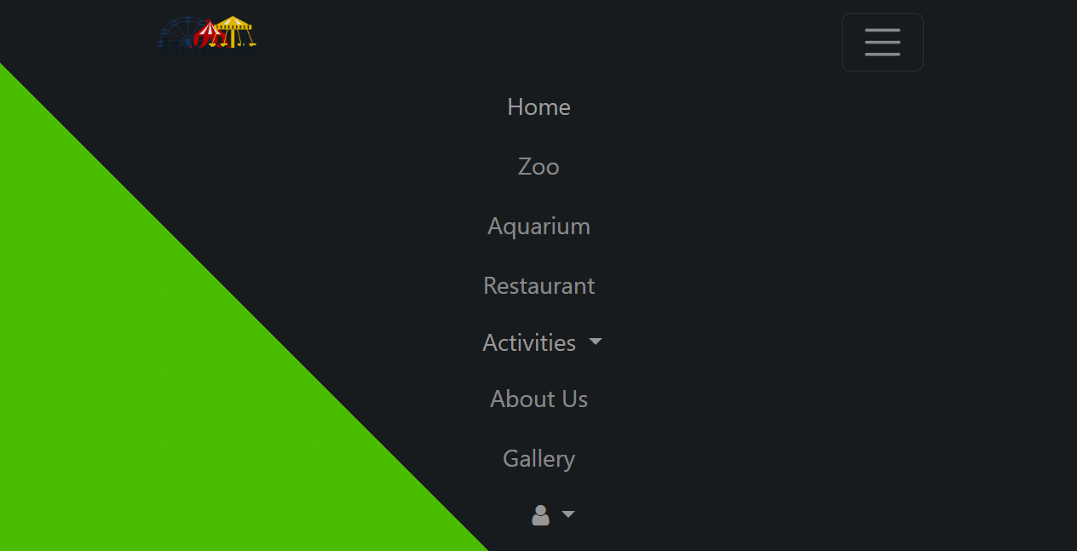

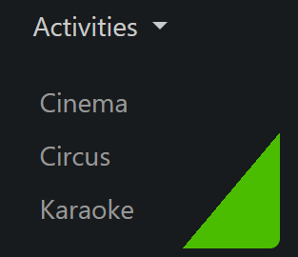

Dropdowns are expanded on hover instead of clicking on them and they have same colors as the navigation bar but in inversed direction.

**Footer:** Design of the footer is made using different column classes of Bootstrap. It has information and copyrights text of this website. Background color is a gradient of Red & Blue and the quick links follow the same pattern to match the scheme of the component. There is an input field for the user to fill in order to subscribe to the website’s newsletter. Just like the navigation bar, it is also present in every webpage of the website.

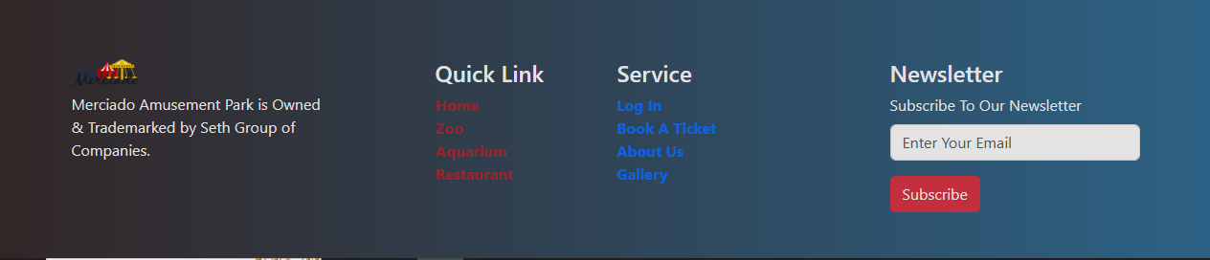

**Homepage:** The homepage starts with a carousel that has attractive videos and images of the park. It has buttons to navigate through the content. Caption of the carousels welcome the guests with text which has animations on start. To match the theme of the picture, color of the text changes depending on the colors of the images/video.

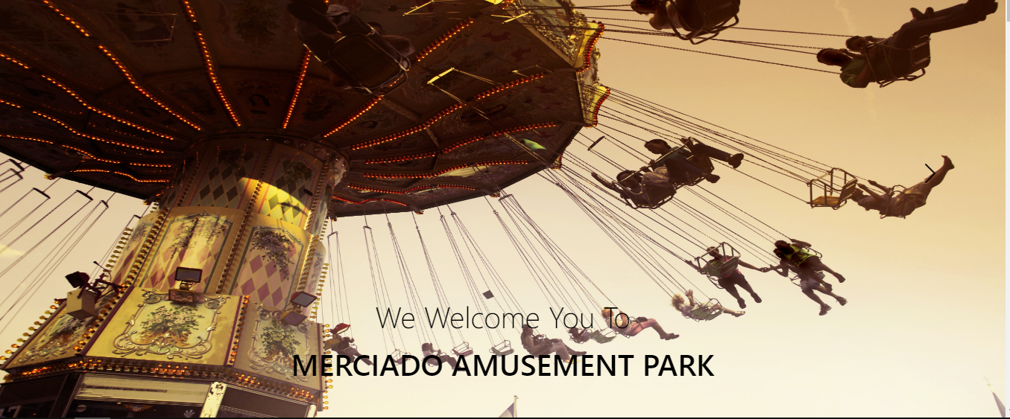

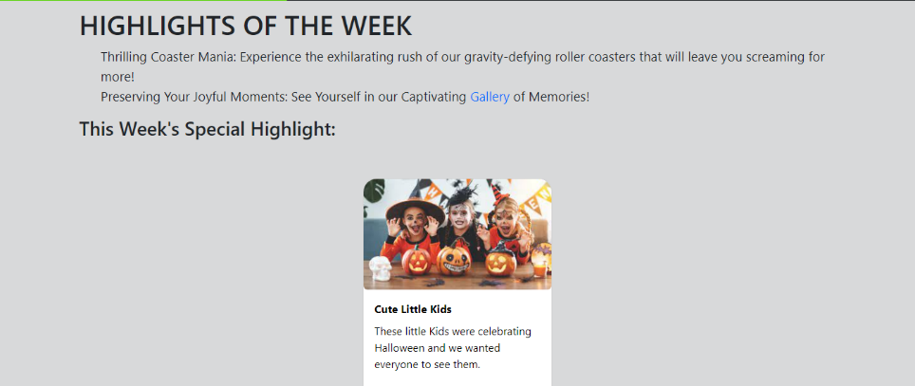Main content of the page starts from beneath the carousel that starts from the highlights of the week. it highlights the “GALLERY” section of the website by showcasing a picture from the gallery. Note that the pictures are a subject to change since the park updates them from time to time.

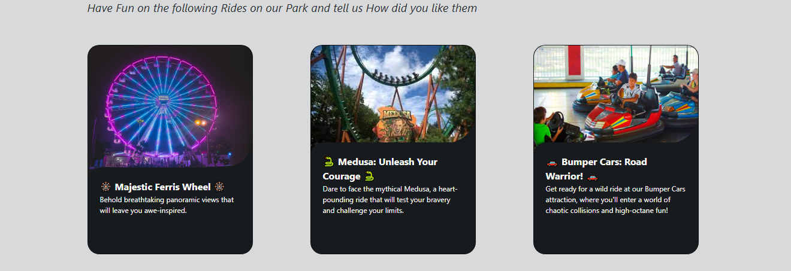**Rides:** Rides of the park include **🎡 Majestic Ferris Wheel 🎡, 🐍 Medusa 🐍, 🚗 Bumper Cars 🚗** etc. There is text below the name of the ride which tells people how awesome these rides are. But these are just introductions.

Explanation and selling of the rides are shown when these cards are hovered upon. Designs are in such a way that text is white while background of card is black which matches the theme of the webpage and blends smoothly along the colors.

**Before After**

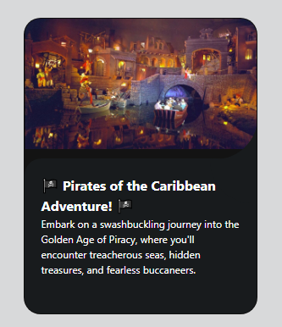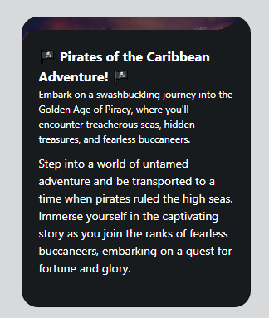

Now comes the main section of this homepage: **BOOKINGS & LOGIN**.

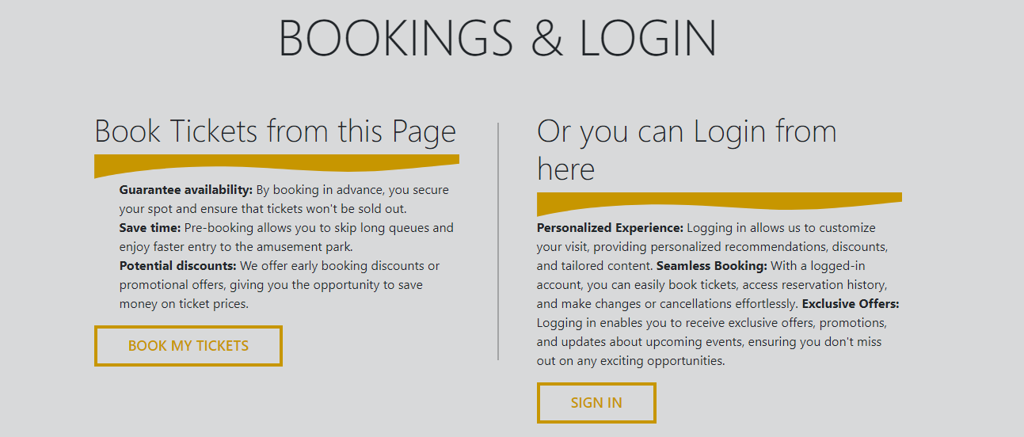A line divides the two sections that make up this part. One section explains to the consumer the advantages of purchasing tickets in advance, such as time saving and discounts. Additionally, it guides the viewer to the ticket booking section. This section’s color scheme is orange and **black.**

The second half describes the benefits of signing in on this website, Such as the ability to book tickets which requires an account. The button functions only on this page, which opens a modal where the user enters his login credentials.

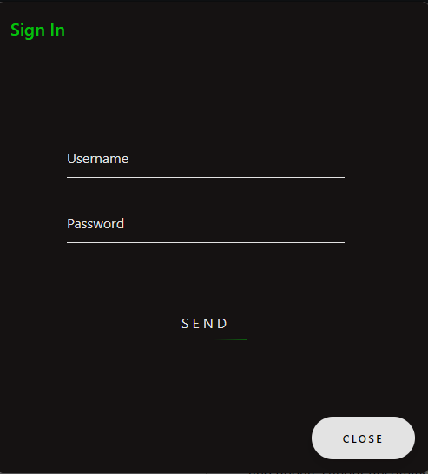

This popup modal consists of two input fields and two buttons. Both the buttons have different designs as they serve a different purpose. Logging in in this site is easier than ever. Just put your username and the password that you set and done!

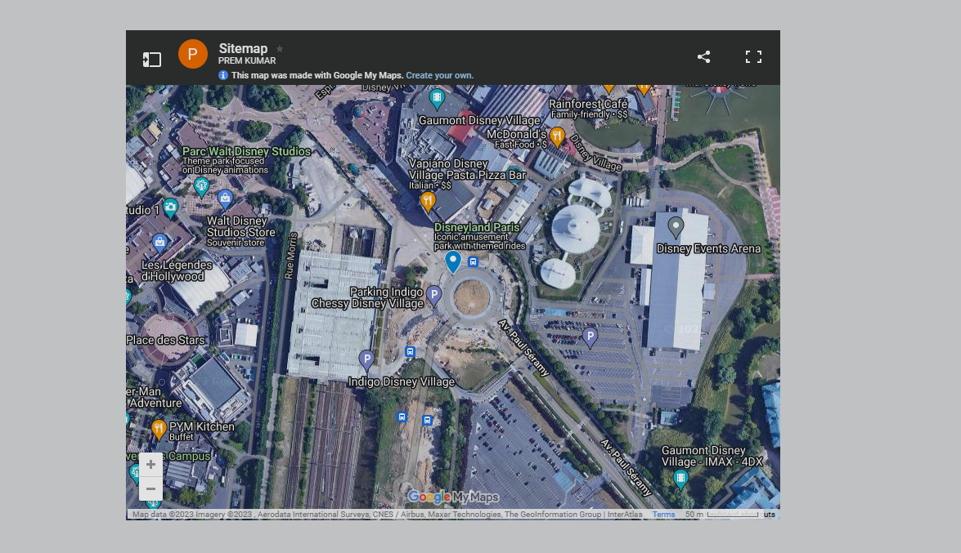 To make it simpler for users to find location, a sitemap has been included. It incorporates Google Maps API into this webpage.

**Zoo & Aquarium:** The styling of the zoo and aquarium’s webpages are similar since both use text and photos to present content.

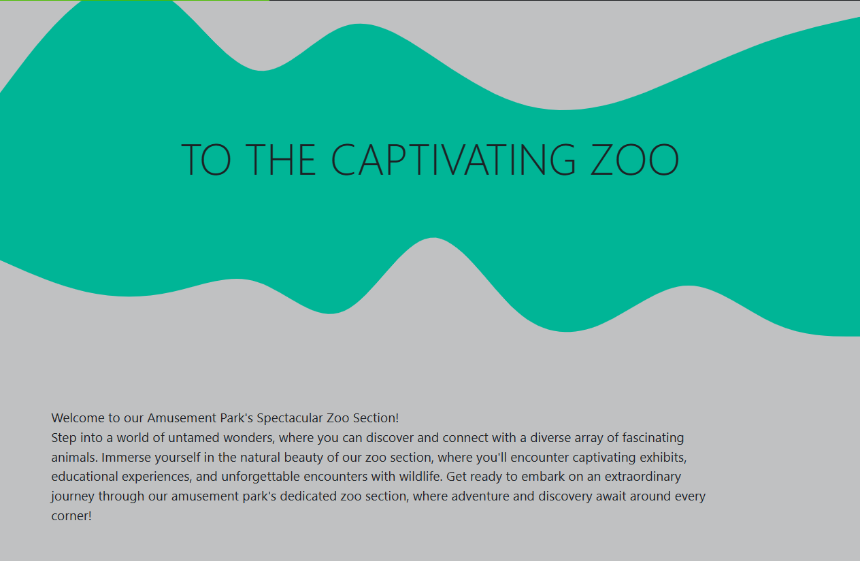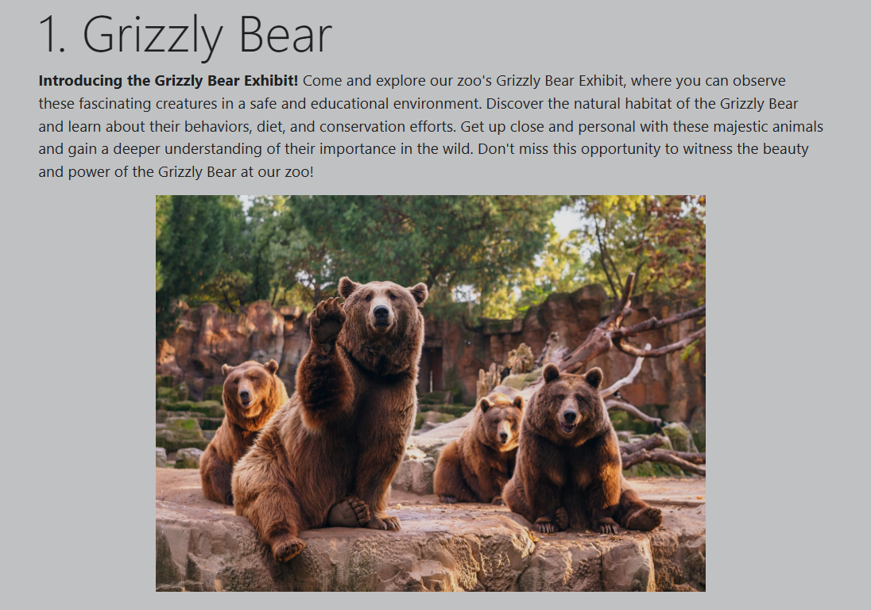

Zoo’s page features a static look presenting the creatures and boosting them to the reader. Both the pages are developed using Bootstrap classes for layout and design.

An addition of fishes swimming across the page has been added using SVGs (Scalable Vector Graphics) in the aquarium page. To make them go from one end to the other the SVGs are placed in marquee element which explains the behavior and smooth animation of these creatures.

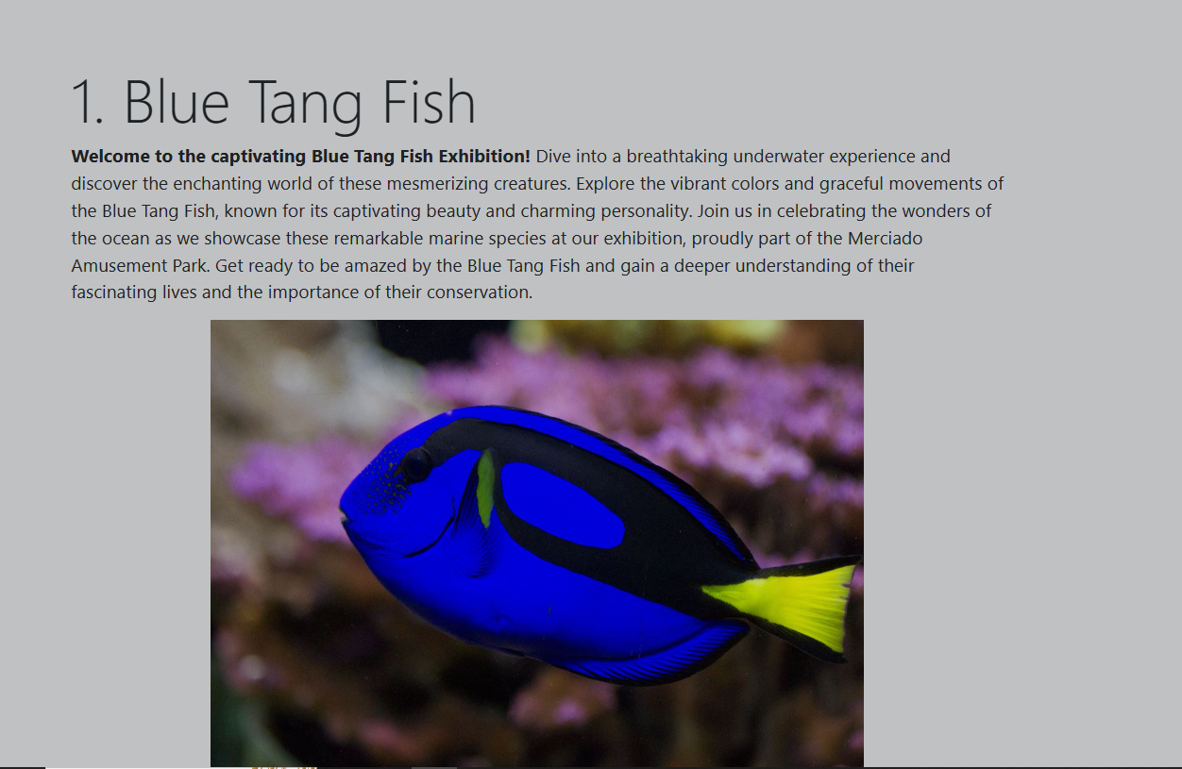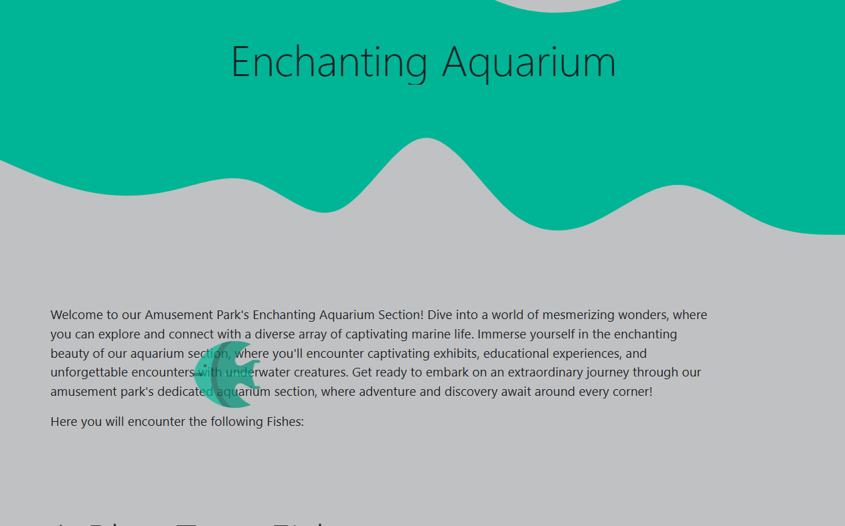

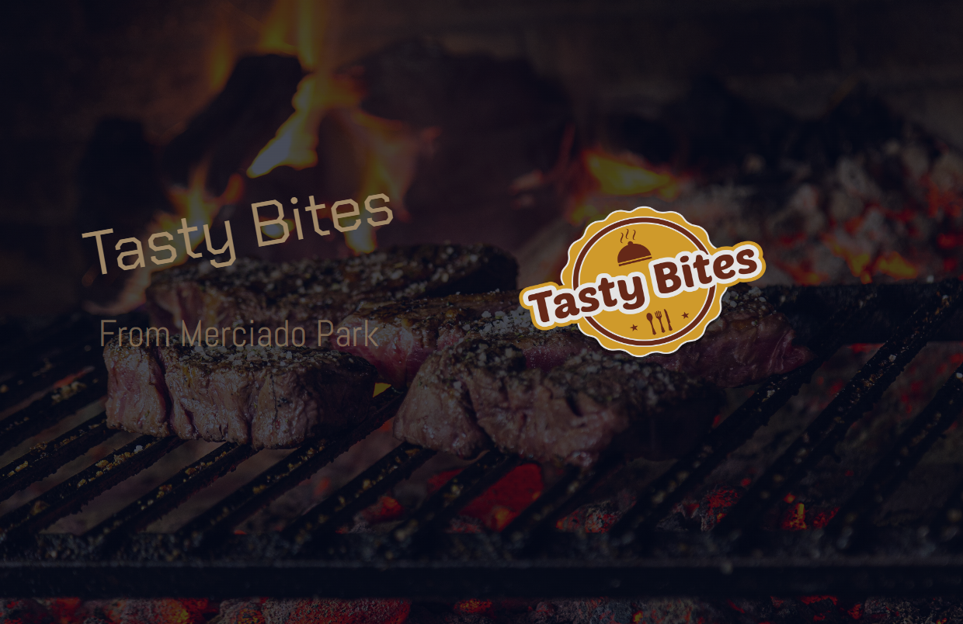**Restaurant:** This page starts from the introduction with a logo of the restaurant. It also shows that this place is made in partnership with the park.

Text disappears from the page on changing the width of this site to give it a good look.

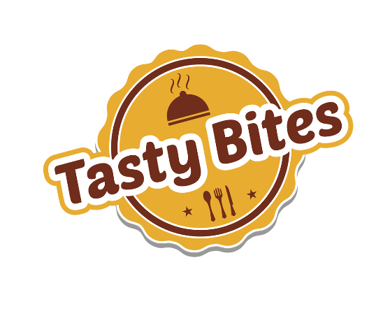

Tasty bites offers a lot of different foods and some of them are shown on their site. It is also always upgrading its menu from time to time which they tell the user at the bottom of the page.

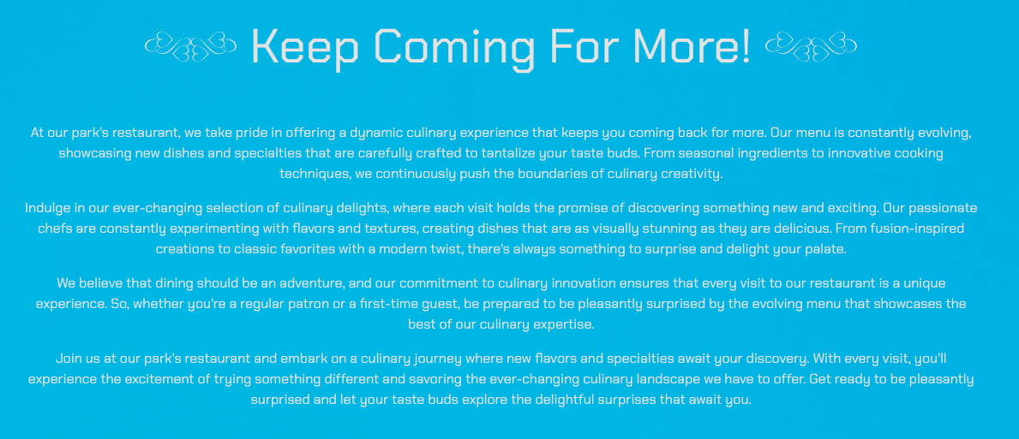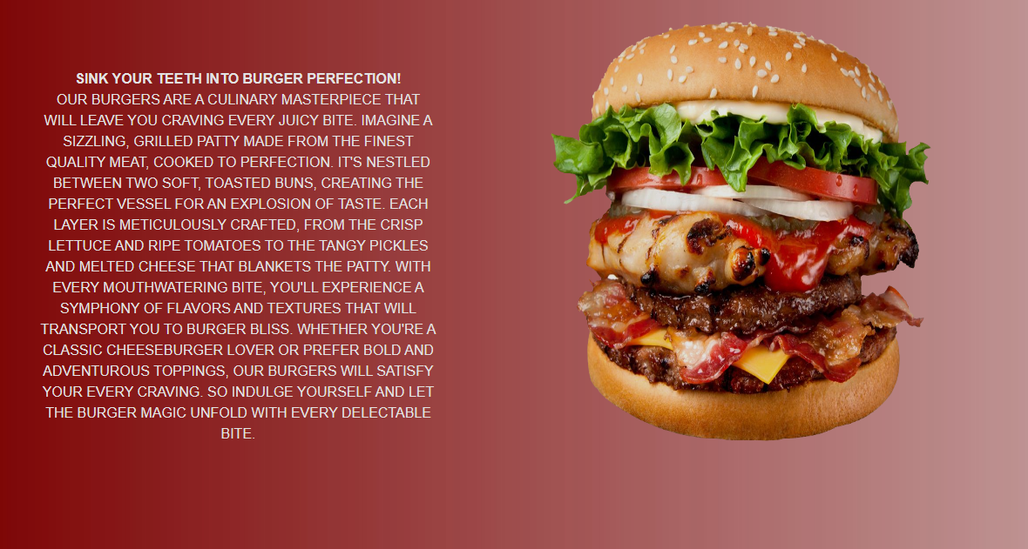Each menu item has been given a separate background color which mixes quite well with the theme of the page. Direction of food and text changes in every 2nd div with the pseudo class selectors. This page doesn’t have a price / buy button since this page is only for the user to read.

For SEO, a big paragraph is added inviting readers to this park and trying out different dishes tasty bites has to offer.

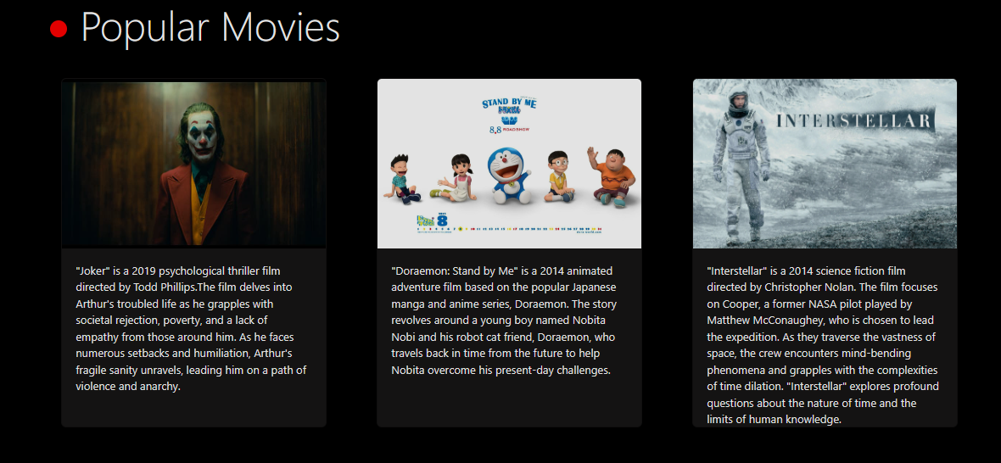**Activity Page:** Merciado Amusement Park has loads and loads of activities to do. Some of them are mentioned in this page. These are watching circus, movies and playing karaoke. Background color is made black to give a feeling of theatres. Popular movies like Avengers, John Wick are shown.

Circus have different types of entertainments some of them mentioned in this page are Fire eating, rope walking etc. they are also shown with text and images for user to read.

**Gallery Page:** Memories are saved and showed in this section in the form of cards with texts behind them which is exposed on hovering the cards.

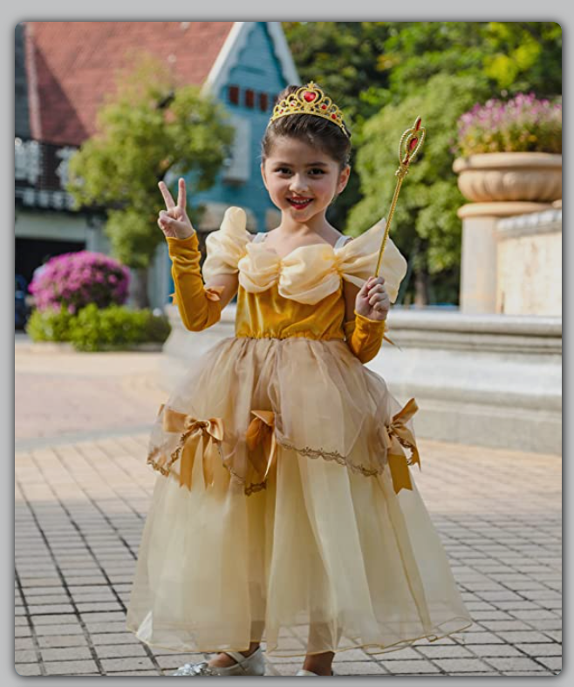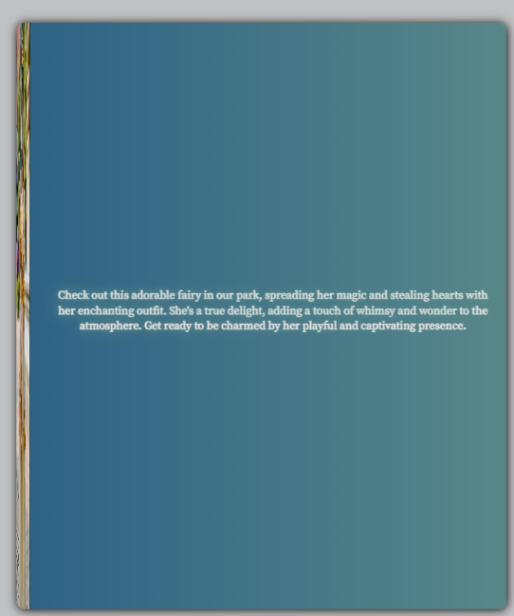

**BEFORE AFTER**

When viewers hover over an image, it gently slides to the left, presenting a beautifully created narrative that compliments the memory recorded. For a fluid transition, duration is kept at 0.5s.

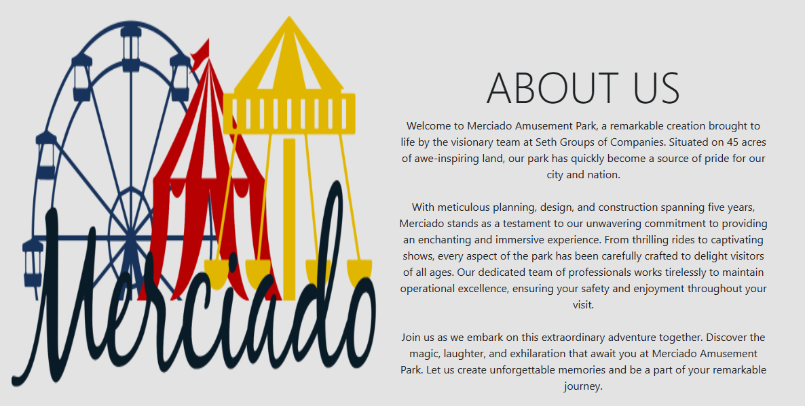**About Us Page:** When consumers visit this page of the website, they will be welcomed with a compelling description of the park. The language underlines the park’s commitment to offering an engaging and immersive experience.

Both the disclaimer and privacy policy are clearly posted on this page ensuring that the viewers are aware of these critical data. The words are presented in a clear and understandable manner for visitors who seek more in-depth information.

To keep a decent design, pictures of park are exhibited along with the text. 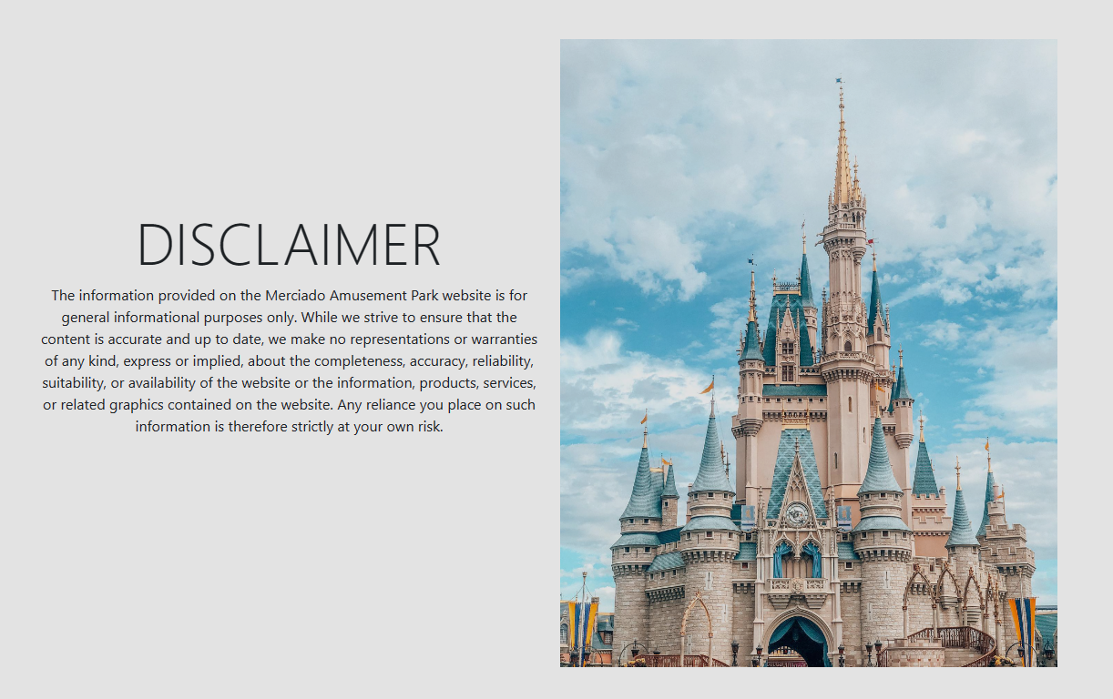

**Ticket Section:** The park has a base ticket price of just $49.99 but is hosting a family deal starting from 20th June, 2023. It offers a variety of deals and discounts which include meals, train rides and free karaoke.

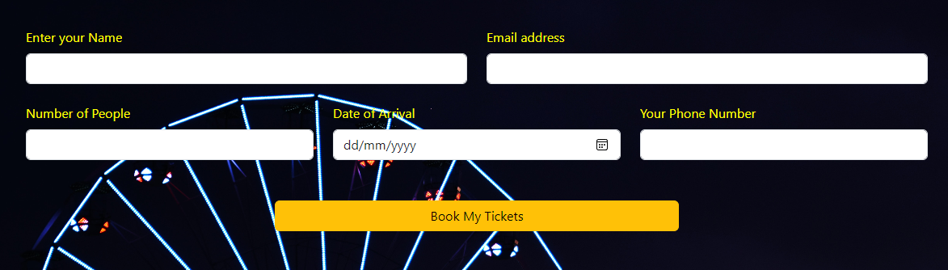**Design:** The website has a color palette of yellow and **black**. The form is there for the users to input their details and enter the date they are arriving on and submit button is to confirm the bookings for the day and their tickets will be reserved in the database.

Scrolling down we can see the cards that have a variety of deals for the families visiting the place. These cards have different hovers of different colors including but not limited to red, green and yellow. To ensure the smooth navigation, this transition takes 0.5s to transform into the colors which you can see. There is a small section of these colors in the corner of the cards indicating which color will their fill be on hovering.

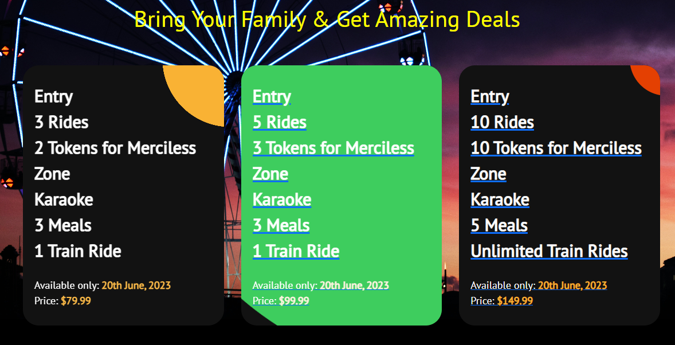

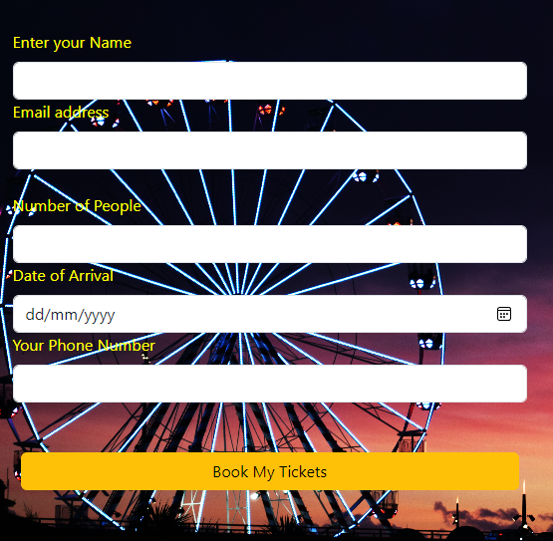The design is also made responsive by the usage of Bootstrap CSS framework.

It changes the view when minimized to at least 600px of width. The display of the div was made flexible using custom CSS and then the flex-direction has been changed to column in the media query section so that each of the form is line wise in the webpage.

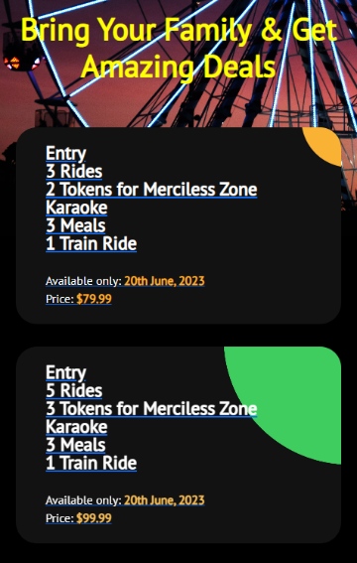

The same styling has been done to the discount section; the difference being the width of the cards. At first, these were aligned next to each other and now beneath.

**Fonts:** PT Sans, Sans-Serif, Montserrat, Chakra Petch

**Languages:** HTML, CSS

**Frameworks/Libraries:** Bootstrap & jQuery

**Sources:** GetBootstrap, Codepen